ICEngineSoft Test Report

Report Date : Wed, Dec 14, 2022 , Time : 1:00:38 AM
Organization : Organisation, Operator : Operator
Data File : 13-12 WCO-LDPE B20.xlsx, Last Modified Date: Wed, Dec 14, 2022,
Config. File : Kirloskar TV1 Engine.xls

Engine Details :

ICEngine set up under test is Kirloskar TV1 having power 5.20 kW @ 1500 rpm which is 1 Cylinder, Four stroke , Constant Speed, Water Cooled, Diesel Engine, with Cylinder Bore 87.50(mm), Stroke Length 110.00(mm), Connecting Rod length 234.00(mm), Compression Ratio 17.50, Swept volume 661.45 (cc)

Combustion Parameters :

Specific Gas Const (kJ/kgK) : 1.00, Air Density (kg/m^3) : 1.17, Adiabatic Index : 1.41, Polytrophic Index : 1.12, Number Of Cycles : 10, Cylinder Pressure Referance : 6, Smoothing 2, TDC Reference :-1

Performance Parameters :

Orifice Diameter (mm) : 20.00, Orifice Coeff. Of Discharge : 0.60, Dynamometer Arm Legnth (mm) : 185, Fuel Pipe dia (mm) : 12.40, Ambient Temp. (Deg C) : 27, Pulses Per revolution : 360, Fuel Type : Diesel, Fuel Density (Kg/m^3) : 836, Calorific Value Of Fuel (kj/kg) : 41600

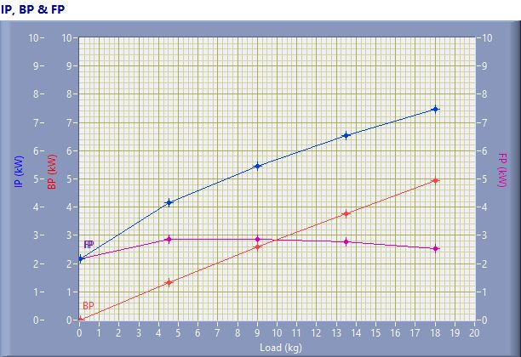

IP, BP & FP

Speed (rpm) | Load (kg) | IP (kW) | BP (kW) | FP (kW)
1548.00 | 0.03 | 2.18 | 0.01 | 2.17
1537.00 | 4.51 | 4.16 | 1.32 | 2.85
1508.00 | 9.03 | 5.46 | 2.59 | 2.87
1465.00 | 13.50 | 6.52 | 3.76 | 2.76
1441.00 | 18.02 | 7.46 | 4.94 | 2.52

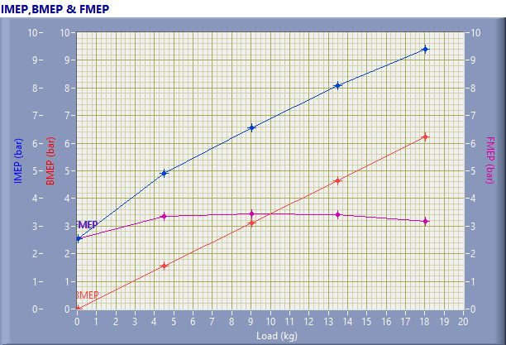

IMEP,BMEP & FMEP

Speed (rpm) | Load (kg) | IMEP (bar) | BMEP (bar) | FMEP (bar)
1548.00 | 0.03 | 2.56 | 0.01 | 2.55
1537.00 | 4.51 | 4.91 | 1.55 | 3.36
1508.00 | 9.03 | 6.57 | 3.11 | 3.45
1465.00 | 13.50 | 8.08 | 4.66 | 3.42
1441.00 | 18.02 | 9.39 | 6.21 | 3.17

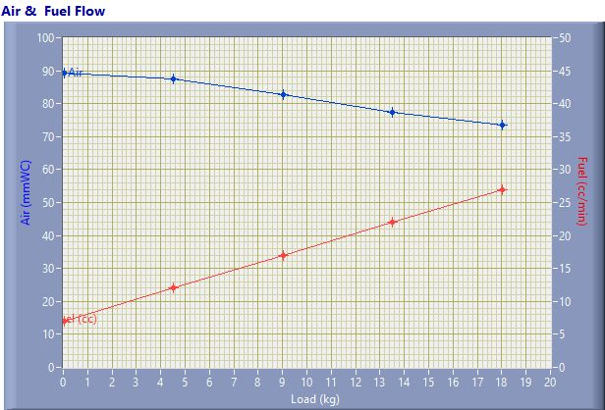

Air & Fuel Flow

Speed (rpm) | Load (kg) | Air (mmWC) | Fuel (cc/min)
1548.00 | 0.03 | 89.15 | 7.00
1537.00 | 4.51 | 87.42 | 12.00
1508.00 | 9.03 | 82.84 | 17.00
1465.00 | 13.50 | 77.51 | 22.00
1441.00 | 18.02 | 73.60 | 27.00

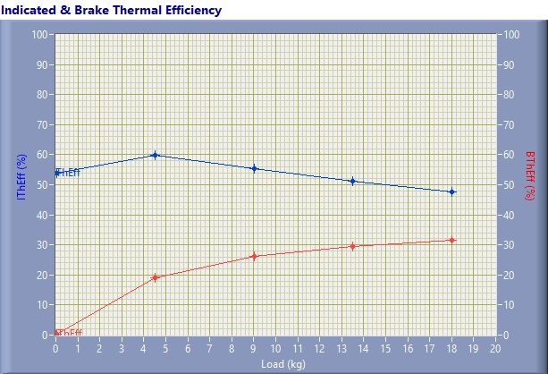

Indicated & Brake Thermal Efficiency

Speed (rpm) | Load (kg) | IThEff (%) | BThEff (%)
1548.00 | 0.03 | 53.76 | 0.24
1537.00 | 4.51 | 59.87 | 18.92
1508.00 | 9.03 | 55.40 | 26.26
1465.00 | 13.50 | 51.16 | 29.48
1441.00 | 18.02 | 47.64 | 31.54

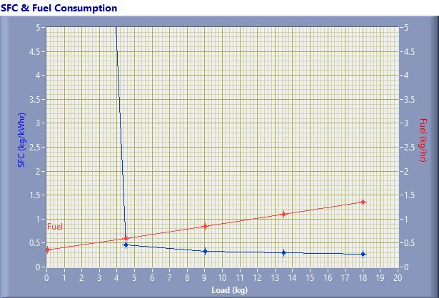

SFC & Fuel Consumption

Speed (rpm) | Load (kg) | SFC (kg/kWh) | Fuel (kg/h)
1548.00 | 0.03 | 36.17 | 0.35
1537.00 | 4.51 | 0.46 | 0.60
1508.00 | 9.03 | 0.33 | 0.85
1465.00 | 13.50 | 0.29 | 1.10
1441.00 | 18.02 | 0.27 | 1.35

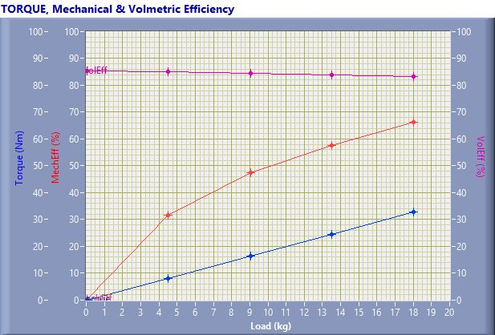

TORQUE, Mechanical & Volmertic Efficiency

Speed (rpm) | Load (Kg) | Torque (Nm) | Mech Eff. (%) | Vol Eff. (%)
1548.00 | 0.03 | 0.06 | 0.45 | 85.27
1537.00 | 4.51 | 8.18 | 31.61 | 85.04
1508.00 | 9.03 | 16.39 | 47.41 | 84.38
1465.00 | 13.50 | 24.50 | 57.62 | 84.02
1441.00 | 18.02 | 32.71 | 66.19 | 83.23

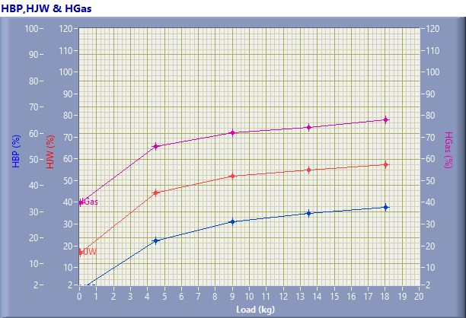

HBP,HJW & HGas

Speed (rpm) | Load (kg) | HBP (%) | HJW (%) | HGas (%) | HRad (%)
1548.00 | 0.03 | 0.24 | 16.54 | 23.21 | 60.02
1537.00 | 4.51 | 18.92 | 25.37 | 21.43 | 34.27
1508.00 | 9.03 | 26.26 | 25.73 | 20.18 | 27.84
1465.00 | 13.50 | 29.48 | 25.46 | 19.64 | 25.42
1441.00 | 18.02 | 31.54 | 25.85 | 20.70 | 21.91

Observation Data

Speed (rpm) | Load (kg) | Comp Ratio | T1 (deg C) | T2 (deg C) | T3 (deg C) | T4 (deg C) | T5 (deg C) | T6 (deg C)
1548 | 0.03 | 17.50 | 38.72 | 42.55 | 38.71 | 37.68 | 126.08 | 101.42
1537 | 4.51 | 17.50 | 38.86 | 48.94 | 38.86 | 40.17 | 184.13 | 139.06
1508 | 9.03 | 17.50 | 38.91 | 53.40 | 38.91 | 42.97 | 240.36 | 178.22
1465 | 13.50 | 17.50 | 38.99 | 57.54 | 39.00 | 45.91 | 302.30 | 221.37
1441 | 18.02 | 17.50 | 39.06 | 62.18 | 39.06 | 50.02 | 388.73 | 276.55

Observation Data

Air (mmWC) | Fuel (cc/min) | WaterFlow Engine (lph) | WaterFlow Cal (lph)
89.15 | 7.00 | 150 | 75
87.42 | 12.00 | 150 | 75
82.84 | 17.00 | 150 | 75
77.51 | 22.00 | 150 | 75
73.60 | 27.00 | 150 | 75

Result Data

Torque (Nm) | BP (kW) | FP (kW) | IP (kW) | BMEP (bar) | IMEP (bar) | BTHE (%) | ITHE (%) | Mech Eff. (%)
0.06 | 0.01 | 2.17 | 2.18 | 0.01 | 2.56 | 0.24 | 53.76 | 0.45
8.18 | 1.32 | 2.85 | 4.16 | 1.55 | 4.91 | 18.92 | 59.87 | 31.61
16.39 | 2.59 | 2.87 | 5.46 | 3.11 | 6.57 | 26.26 | 55.40 | 47.41
24.50 | 3.76 | 2.76 | 6.52 | 4.66 | 8.08 | 29.48 | 51.16 | 57.62
32.71 | 4.94 | 2.52 | 7.46 | 6.21 | 9.39 | 31.54 | 47.64 | 66.19

Result Data

Air Flow (kg/h) | Fuel Flow (kg/h) | SFC (kg/kWh) | Vol Eff. (%) | A/F Ratio | HBP (%) | HJW (%) | HGas (%) | HRad (%)
30.75 | 0.35 | 36.17 | 85.27 | 87.58 | 0.24 | 16.54 | 23.21 | 60.02
30.45 | 0.60 | 0.46 | 85.04 | 50.59 | 18.92 | 25.37 | 21.43 | 34.27
29.64 | 0.85 | 0.33 | 84.38 | 34.76 | 26.26 | 25.73 | 20.18 | 27.84
28.67 | 1.10 | 0.29 | 84.02 | 25.98 | 29.48 | 25.46 | 19.64 | 25.42
27.94 | 1.35 | 0.27 | 83.23 | 20.63 | 31.54 | 25.85 | 20.70 | 21.91

